



**Module Code & Module Title**

**CS6P05NI Final Year Project**

**Assessment Weightage & Type**

**40% FYP Final Report**

**Semester**

**2020 Spring**

**Student Name:**

**London Met ID:**

**College ID:**

**Internal Supervisor:**

**External Supervisor:**

**Assignment Due Date:**

**Assignment Submission Date:**

**Word Count (Where Required):**

*I confirm that I understand my coursework needs to be submitted online via Google Classroom under the relevant module page before the deadline in order for my assignment to be accepted and marked. I am fully aware that late submissions will be treated as non-submission and a mark of zero will be awarded.*

# Abstract:

# Table of Content:

# Table of Tables:

# Table of Abbreviation:

# Chapter 1: Introduction

## Project Description:

The world is rapidly moving toward digitalization for everything, from buying stuff you need to even ordering food to your doorstep. Human beings are always searching for an upgrade on everything; they want things to be faster, easier, cheaper, and more convenient. All most every aspect of our lives is being modernized and improved but in the context of Nepal searching for rental properties and giving out properties for rent is still old school.

Speaking statistically, according to the census of Nepal 2011 also 12.81 percent of household family which is about 694,701 reside in rented places in Nepal. (Government of Nepal, 2011). In Kathmandu valley (including Lalitpur and Bhaktapur districts) alone 322,599 households stay in rental units. (Government of Nepal, 2011). And these data are a decade old data it could have well doubled the amount of rental units used in the current year 2021.

Many people have difficulty searching for rental places. They have to visit many places manually in search of proper rental places. Similarly, many people who have property struggle to find a suitable tenant. In such a digital age people, searching for rental places and suitable tenants manually does not make sense, and to close this gap between landlords and tenants I have decided for my final year project to build a rental property finding and management application.

## Current Scenario:

Real estate sector which includes house renting as well in the valley is undergoing an urban explosion rather than managed urban growth. As per the 2011 census, the urban areas in the valley are expanding annually by the rate of 6.67%. (Government of Nepal, 2011). As per the recent figure of Nepal Rastra Bank (The Central Bank of Nepal), there has been a total of Nepalese Rupees (NRs.) 88 billion worth of investment in real estate and housing sector. (www.nrb.org.np/, 2022). According to the Census of Nepal 2011, 694,701 (Government of Nepal, 2011) households stay in rental units and among them a lot may them may face various problems while renting a house unit.

## Problem Domain and Project as a Solution:

### Problem Domain:

The problem domain that I want to explore and bring some betterment through my final year project is the house renting sector of Nepal and especially in the city areas. When searching for rental places in Nepal people go through a lot of trouble especially if you are searching for rental places where you are new and you don’t know anybody. Trying to address this problem and making the whole process searching for rental places easier I have built a system which I call RentGhar. Some common problems that people face regarding rental properties are:

* People search for suitable rental places manually by visiting different places door to door, searching for places manually will lead to having limited options.
* Landlords who have good rental places also search for favorable tenant manually which lead to the rental place to be vacant most of the time.
* There are some related applications but people do not prefer to use it because these applications are not convenient, they are not user-friendly and not reliable.
* Although, people find rental places as well as landlord find tenants they do not find satisfactory place or tenants in most cases.
* Some landlords over-charge the tenants for the rental places.

### Project as Solution:

The application that I have created solves the discussed problems in the following ways:

* With the application people can search for rental places in a lot more larger area than they could manually. As well as landlords with good rental places can reach out to more people as well.
* The application will be easy to use and user-friendly.
* The users can give rating to the rental property as he/she finds.
* A feature for cost estimation of a given property will be included in the application for the tenant to check if the landlord is over-pricing the place.
* People who are interested in a place can immediately comment on the property and do any enquiry about the property.

## Aim and Objectives:

### Aim:

The aim of this project is to create a user-friendly and reliable house rental finding and management system to help people find suitable places to live and help landlords to find suitable tenants.

### Objective:

* To try to solve the problems of people who live in rented housing units with my final year project.
* To learn about adobe XD for designing and come up with the initial design for the application within 3 weeks.
* To learn and understand Html, CSS and JavaScript for the frontend of the application within 1 month and start the application development process.
* To learn and understand PHP programming and its framework Laravel for the backend of the application within 1 month for API programming and application development process.
* To understand the concept and implementation of database management system in about 3 weeks to implement the application database using MySQL.
* To learn and understand various testing concepts within 2 weeks to carry out the testing phase of the application.
* To learn and implement about various deployment techniques within 2 weeks to deploy the application.
* To research and learn various concepts on software development to develop a fully functional web application by end of the final year.

## Structure of the Report:

### Background:

The background section of the report provides a better understanding of the project by discussing about the end users of the application and for whom the project is created. It clarifies the technical aspects related to the project. It also provides a better overview of similar projects and comparison between the system and other similar projects.

### Development:

The development section of the report provides an understanding of how the project is going to be developed. It explains the selected as well as the considered methodology and the different phases of the methodology. It includes the survey results which was taken for the project development. It includes the about all the diagram and design process before starting the development phase. It includes about the development of core feature of the system.

### Testing and Analysis:

The testing and analysis section of the report provides an understanding of the testing done for the project. It also consist the information related to the optimal solution of the project, evaluation and operation of the system.

### Conclusion:

The conclusion section of the report provides an overview of the issues that the system may face. The advantages and limitations of the system and what possible upgrades that the system can go through.

# Chapter 2: Background

## About the End Users:

This project is targeted toward the general public who are searching for rental places as well as audience who are searching for tenants. Anyone who wants to post their property for vacancy can post their property with various detail, photos as well as the location of their property. And those who want to search for rental property can log in and search property of their need. The system saves the time of the end user my allowing them to search for places and tenant from the comfort of their own home.

## Understanding the Solution:

### Overview of the system:

The system is a Web-bases rental place finding application named “RentGhar”. The main objective of the application is to provide a platform for the users to upload their rental property and find tenants who are interested in renting the property.

### Technical terms and definitions:

* + - 1. **Code Editor:**

Visual Studio Code, also known as VS Code is a code editor developed by Microsoft. It is a code editor redefined and optimized for building and debugging modern web and cloud application. It has many extension for Html, CSS, Javascript, Php and Laravel, which are help full for the development of the system. (code.visualstudio.com, 2022)

* + - 1. **Database:**

A database is a structured collection of data. To add, access, and process data stored in a computer database, we need a database management system and MySql is the most popular open source SQL database management system. For this project because of its easy to use and easy integration with Laravel, MySql DBMS is used in this project. (dev.mysql.com, 2022)

* + - 1. **Web application framework (Laravel):**

Laravel is a back-end PHP-based and open-source framework which is used for building a wide range custom web applications. It’s an entirely server-side framework that manages data with help of Model-View-Controller (MVC) design. Because of the easy learning curve of the framework, Laravel is selected as the main framework of the project.

## Functions and Features:

### Register:

The user can register to the web application to use it.

* + 1. **Login:**

After the user registers the user can log in to the system.

* + 1. **Post Property:**

After the user is logged in the user can post their property with various details.

* + 1. **Add rating and Comment:**

The user can view property posted by other user and rate it and leave enquiry about the property.

* + 1. **View Property Detail:**

The user can view the details of the property posted by other users.

* + 1. **Search for Property:**

The user can search for properties according to the location of the property.

* + 1. **Manage tenant:**

A user has a simple tenant management system.

* + 1. **Online payment:**

A user can pay online to the landlord for the rent of the property.

* + 1. **Notification:**

A user can send notification to the tenant he has registered in the tenant management.

* + 1. **Nepali language support:**

The system supports nepali language in some sections of the application.

* + 1. **View blogs:**

The user can view blog post posted by the admin.

* + 1. **Approve property:**

The admin can approve the property posted by the user.

## Similar Projects:

### DalayDai:

DalayDai.com is a free online real estate buying and selling platform. The application has various section including Home page, Construction page, Profile page, Favourites page and other pages. This app has construction section which leads to various stores selling construction related materials. This page has a property listing page where we can list various features of the property. It has favourites page which shows the properties that the user has marked favourite. The app also has a home loan section will redirects the user to apply for a home loan. From this app users can buy or rent various real estate or housing properties. This app has various property categories (https://dalaydai.com, 2021)

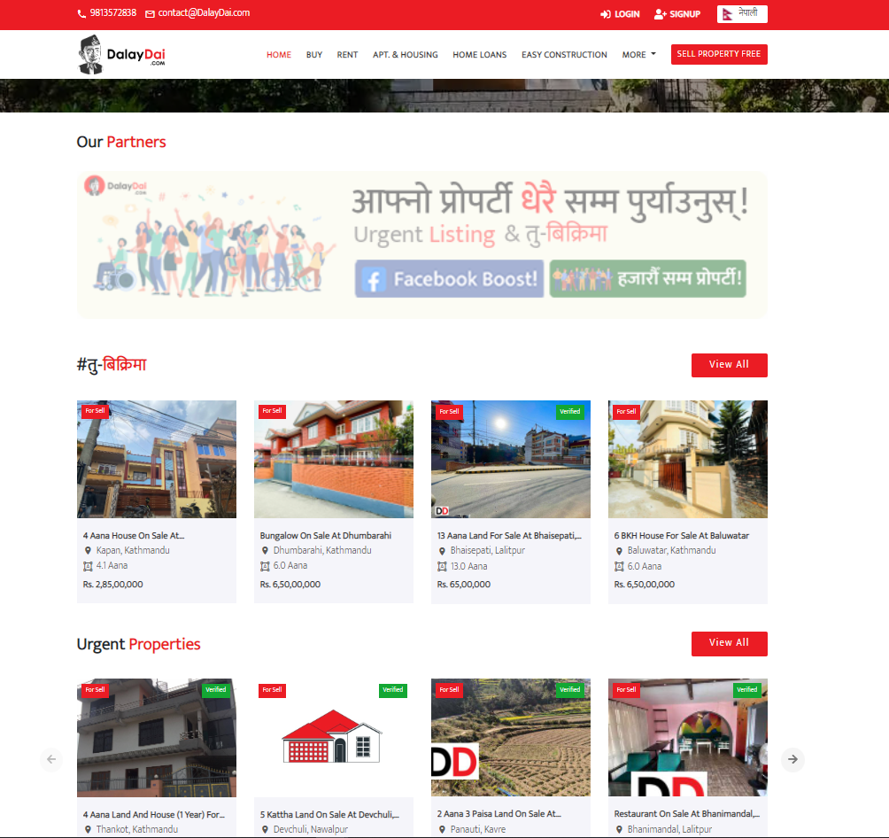

Figure 1: Similar System DalayDai Home page

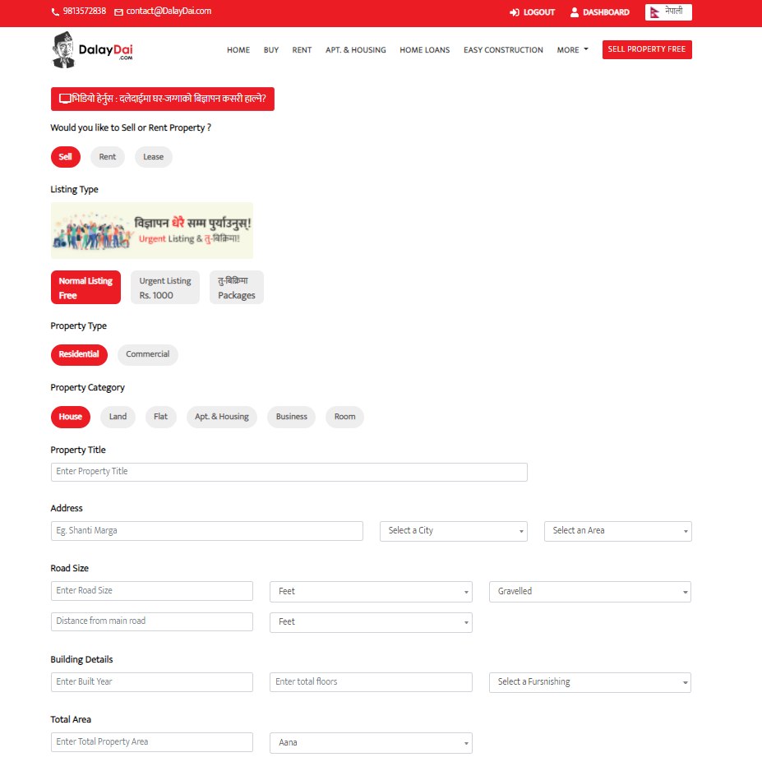

Figure 2: Similar system DalayDai Submission form

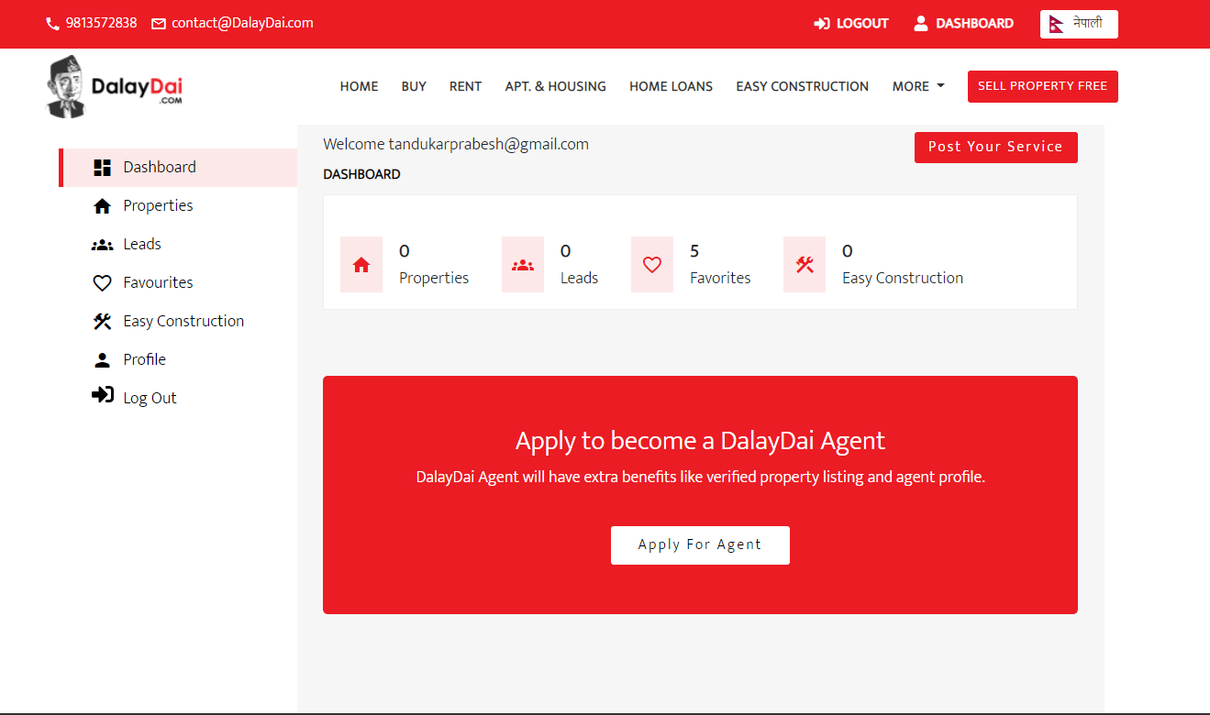

Figure 3: Similar System DalayDai Dashboard page

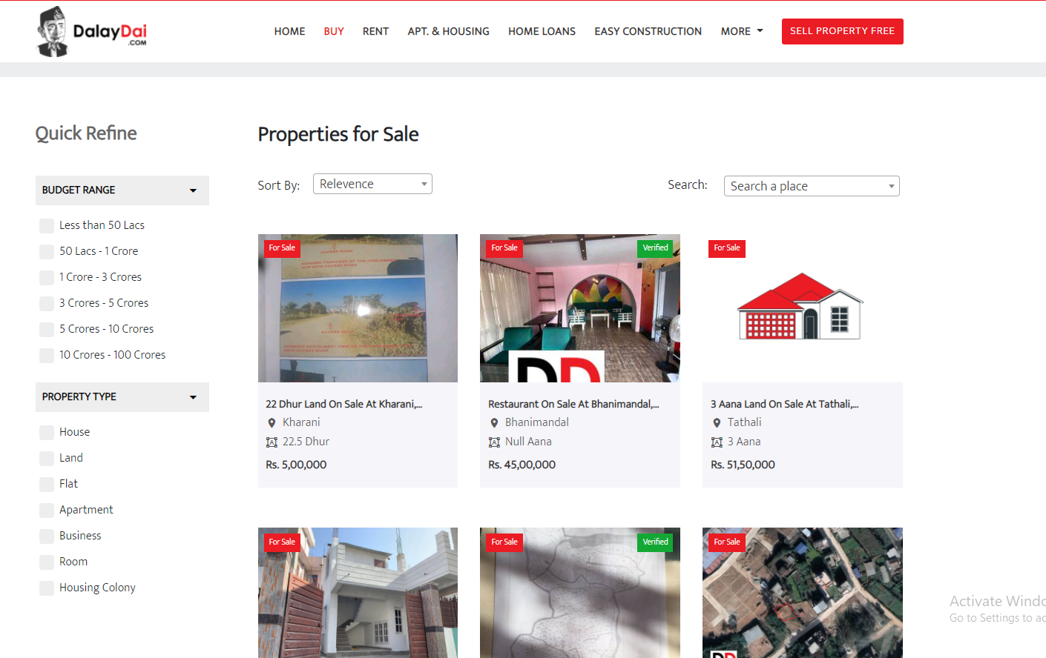

Figure 4: Similar System DalayDai Search

### Basobas:

Basobas is an online real estate buying and selling platform. They include various real estate properties like Land, House etc. The have both paid and free submissions/ memberships for users. Paid users will have more priority in listing properties. The app has home page, property page, property addition page saved page and more page. The app also has a home loan section will redirects the user to apply for a home loan. The app has various categories section for various real estate category. The app also has article section where the app shows various articles. (basobaas.com, 2021)

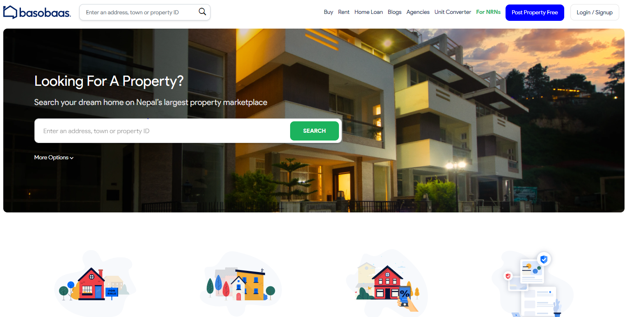

Figure 5: Similar system Basobas home page

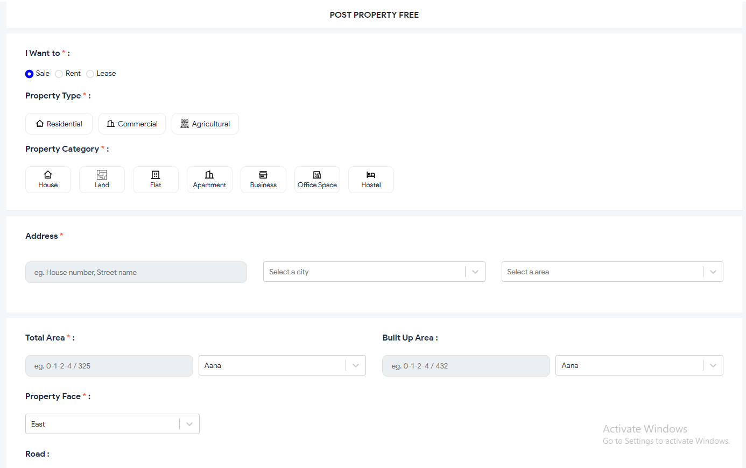

Figure 6: Similar system Basobas post property page

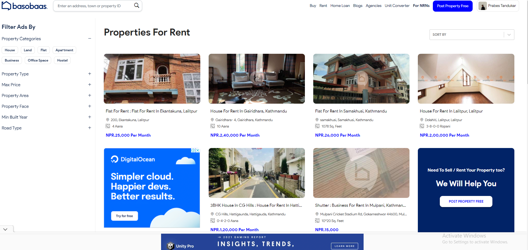

Figure 7: Similar system Basobas Search property page

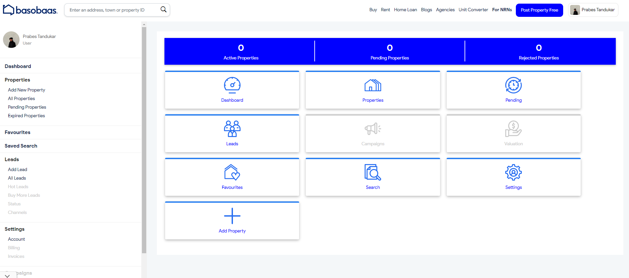

Figure 8: Similar system Basobas Dashboard

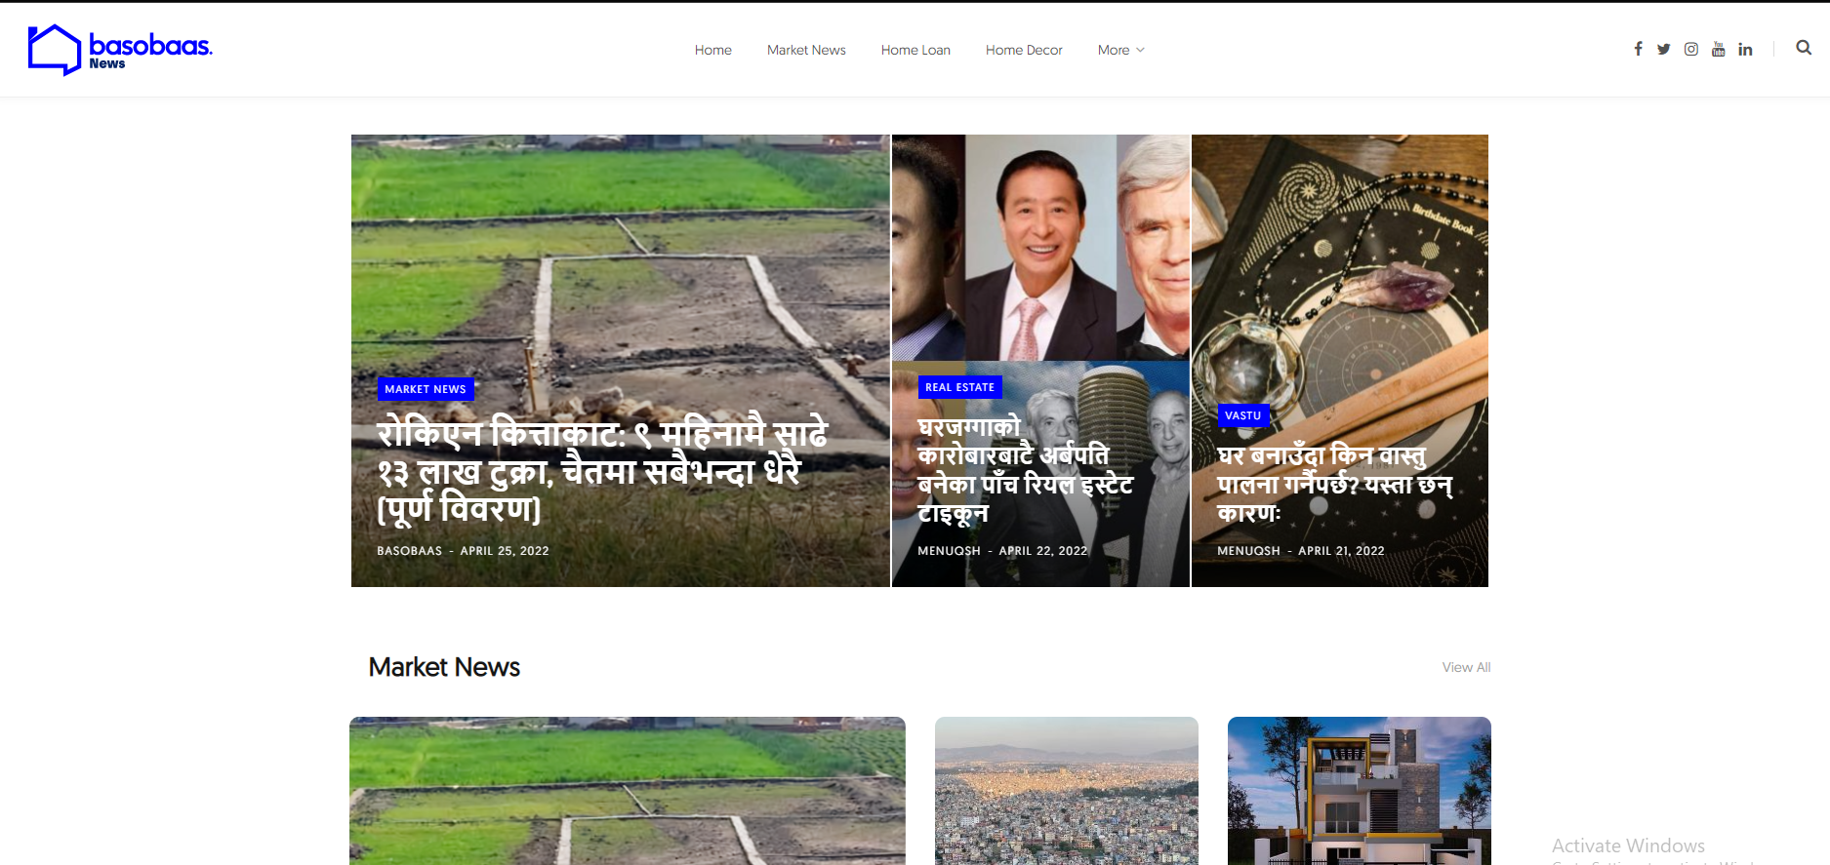

Figure 9: Similar system Basobas Blog page

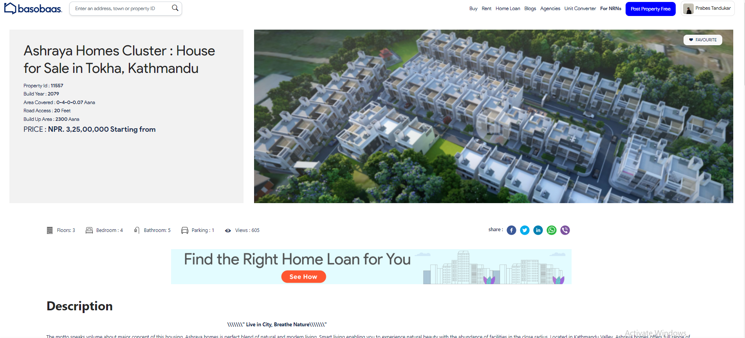

Figure 10: Similar system Basobas property detail page

### 99 acers:

99 acers is India’s No. 1 property portal. It deals with various aspects of a customer’s need in the real estate industry. It is an app where buyers, sellers and brokers/agent can exchange information about real estate properties quickly. Users can advertise a property, search for a property, browse through properties, and keep themselves updated with the latest news and trends in the real estate sectors. It has various pages in the app, like home page, shortlisted page, profile page. It has articles related to real estate for the users. It shortlists property according to various cities. (www.99acres.com, 2021)

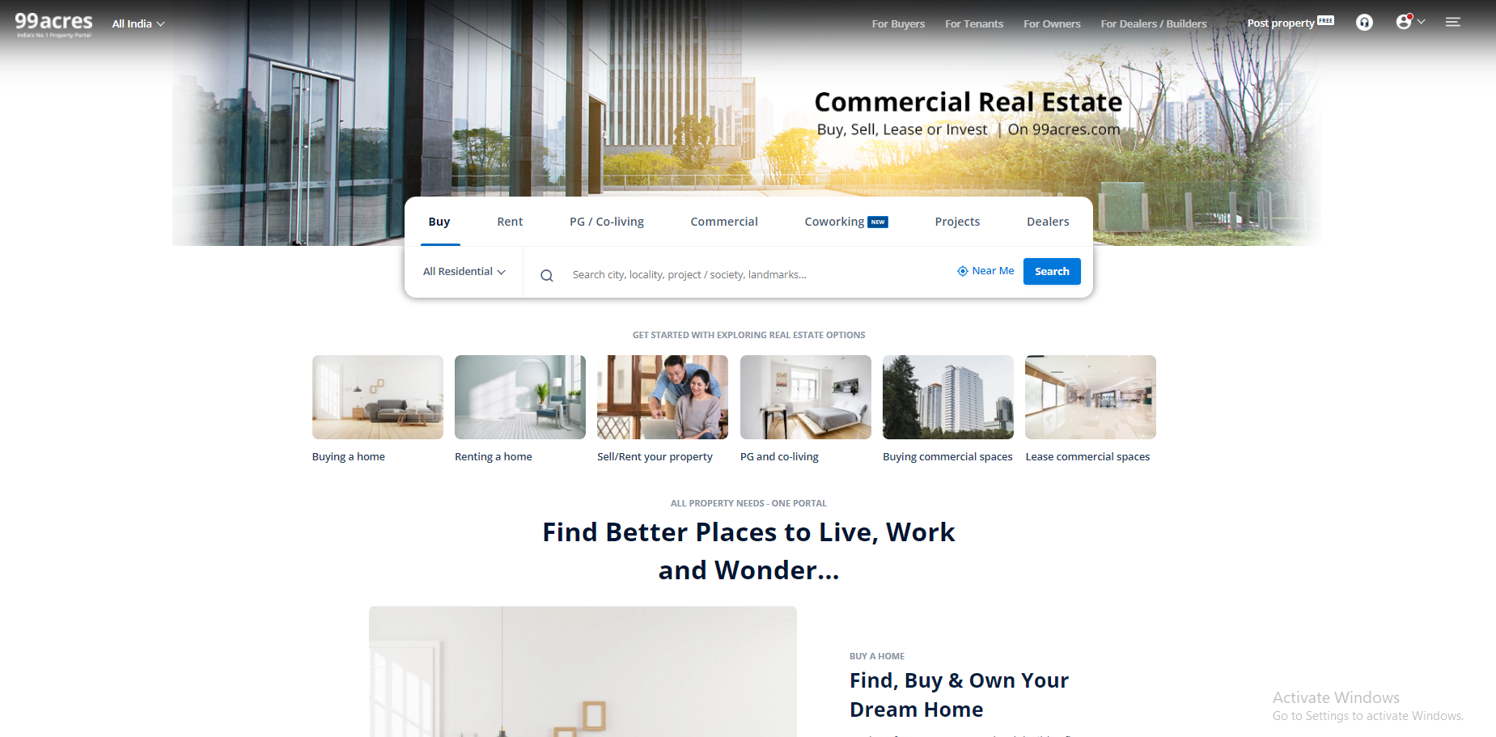

Figure 11: Similar system 99acers home page

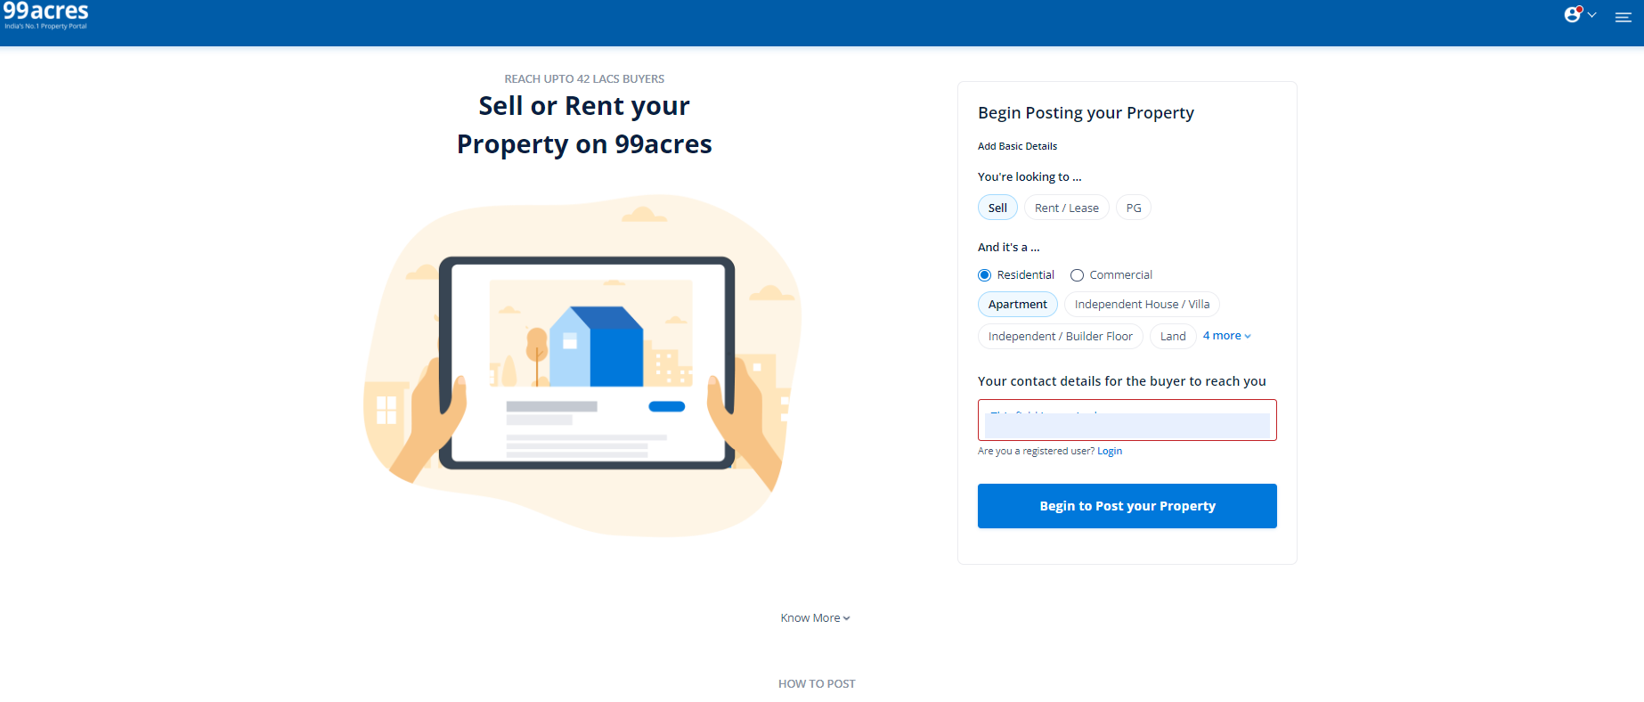

Figure 12: Similar system 99 acers submission form

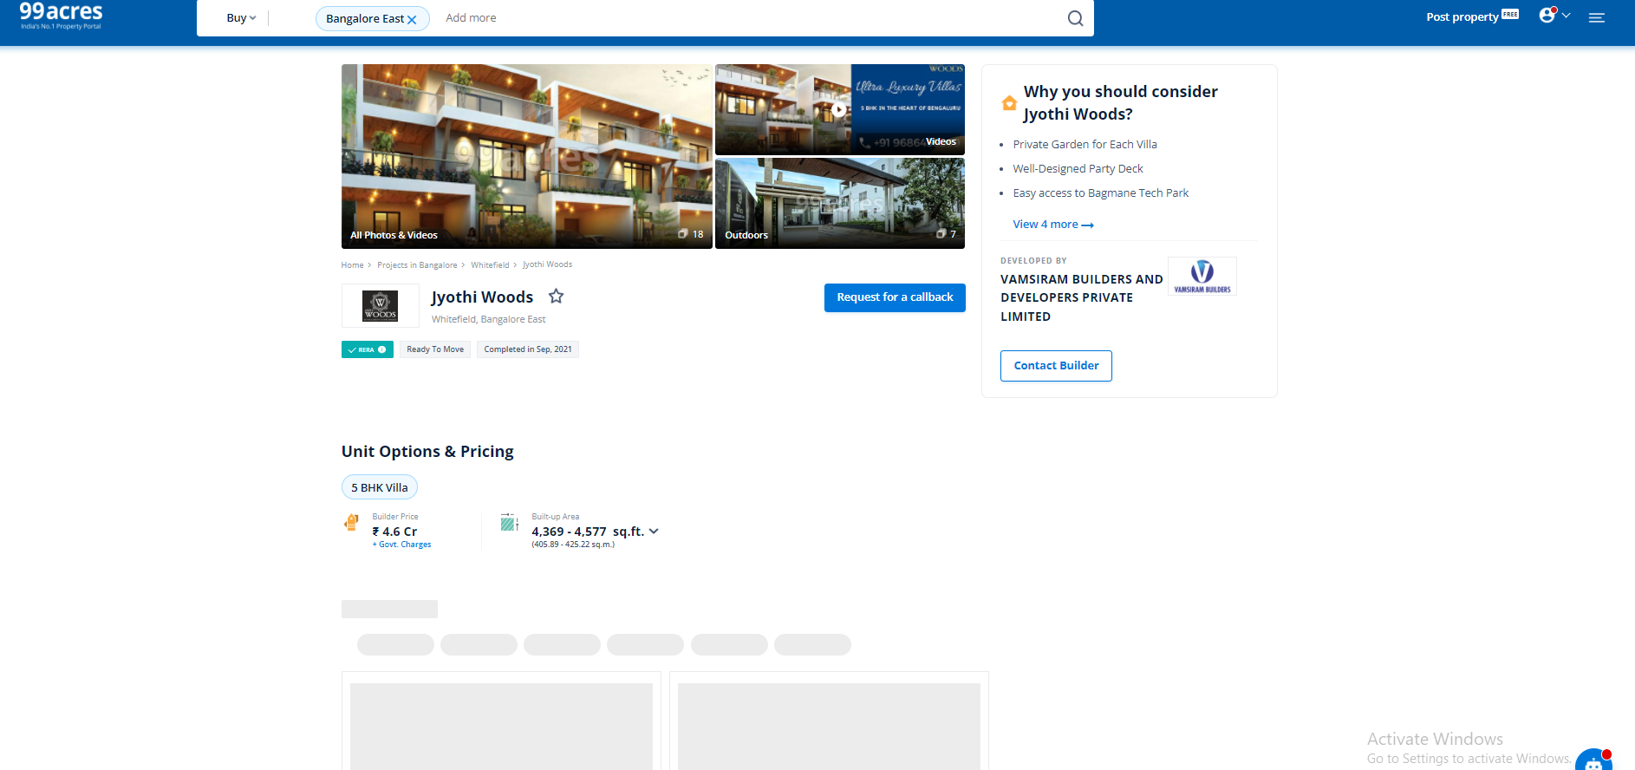

Figure 13: Similar system 99 acers property detail page

## Comparisons:

|  |  |  |  |  |  |
| --- | --- | --- | --- | --- | --- |
| **S.N** | **Features** | **DaleyDai** | **Basobas** | **99acers** | **This project** |
| 1. | Home Section | Yes | Yes | Yes | Yes |
| 2. | Construction stores information | Yes | No | No | No |
| 3. | Rating Properties | No | No | No | Yes |
| 4. | Map view of location | Yes | No | No | Yes |
| 5. | Easy to use | Yes | No | No | Yes |
| 6. | Provide management feature | No | No | No | Yes |
| 7. | Search | Yes | Yes | Yes | Yes |
| 8. | Comment/Query on property detail | Yes | Yes | Yes | Yes |

Table 1: Similar project comparison table

On a conclusive note, all these applications are focused on all the aspects of the real estate business. But my application will be solely focused on finding rental places. Due to distributed focus of these applications in various sectors in the real estate business it does not provide much facility for users renting properties. My application will solely focus on users renting properties and try to provide better facilities for user who are solely focused on renting properties. Therefore, the user that only want to rent property will benefit from this app. The user can review properties and leave comments on properties.The user can set some management tools to manage the tenants that stay in their property and in case of any queries they can contact and leave a message through the contact us page.

# Chapter 3: Development

## Considered Methodology:

### Evolutionary Prototype Model:

Reasons for considering the Model:

* Interaction with the client/user is frequently done.
* The developer can get user feedback on the system quickly.
* Due to regular interaction with client regularly prototyping improves the final product.

Reason for not choosing Prototype Model:

* The client may mistake the prototype of the software for the final product.
* The requirement of the clients may change constantly which may lead to poor documentation.
* The requirements can change and be regularly updated which may extend the original plan, which will increase the complexity of the system.

### Rational Unified Process (RUP):

Reasons for considering the Model:

* The development time required is less due to reuse of components.
* This is a complete methodology in itself with an emphasis on accurate documentation.
* Client/End user have the freedom of giving constant feedback.

Reason for not choosing the Model:

* RUP methodology require the team members or developers to be highly skilful and expert in their respective field.
* The development process is too complex and disorganized.
* The emphasis on integration in development can affect other quality checking phases as well as the testing phase of the development cycle. (www.my-project-management-expert.com, 2022)

### Iterative waterfall model:

Reasons for considering the Model:

* It is easily adaptable to the ever changing needs of the project as well as the client.
* Risks are identified and resolved during iteration; and each iteration is easily managed.
* Parallel development can be planned.

Reasons for not choosing this model:

* More resources may be required.
* Although the cost of change is lesser, but it is not very suitable for changing requirements.
* More management attention is required. (www.professionalqa.com, 2022)

## Selected Methodology:

### Scrum:

To complete the application I have chosen the scrum methodology as my selected software development methodology. Scrum is a framework within which we can address the complex adaptive problem while productivity and creativity of delivering products are at the highest possible values. It uses an iterative process.

Scrum is a framework that helps teams work together. It encourages teams to learn through experiences, self-organize while working on a problem, and reflect on their wins and losses to improve continuously. (Scrum.org, 2021)

Traditionally, Scrum is run in a sprint, which are usually two-week to four-week long working sessions with specific deliverables due at the end. There are two additional Scrum events. Daily stand-ups, as the name suggests, happen once a day. These are an opportunity for the Scrum team to connect for 15 minutes and coordinate daily activities. The second event—the sprint retrospective—happens once the sprint is over. During the sprint retrospective, which will be run by the Scrum master, the team has a chance to reflect on their sprint and make adjustments for future sprints. (atlassian.com, 2021)

**Typical Scrum Events:**

1. Organize backlog

2. Hold a sprint planning session

3. Start Scrum sprint

4. Host daily Scrum stand-ups

5. Present work during the sprint review

6. Connect and reflect during the sprint retrospective

**Scrum Artifacts:**

1. Product backlog: The product backlog is the master list of work that needs to be done.

2. Sprint backlog: The sprint backlog is the collection of work or products a team has committed to for the duration of a Scrum sprint.

3. Product increment: Product increment is what you will deliver at the end of a sprint.

(Scrum.org, 2021)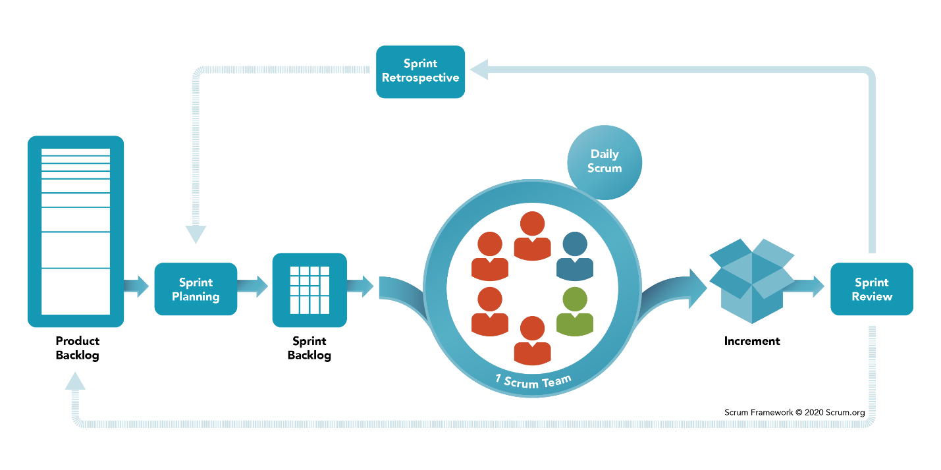Figure 1:Scrum Methodology diagram

Reasons for choosing scrum:

* It is adaptable and flexible.
* This model insures the whole development of the product happens in an efficient manner.
* It ensures higher user satisfaction.
* It provides improves quality of product development.
* It helps to deliver projects faster.

A detailed description of the methodologies can be view in the Appendix section.

## Phases of Methodology

## Survey Results

### Pre-Survey Results

### Post-Survey Results

## Requirement Analysis

## Design

## Implementation

# Chapter 4: Testing and Analysis

## Test Plan

### Unit Testing, Test Plan

### System Testing, Test Plan

## Unit Testing

## System Testing

## Critical Analysis

# Chapter 5: Conclusion

## Legal, Social and Ethical Issues

### Legal Issues

### Social Issues

### Ethical Issues

## Advantages

## Limitations

## Future Work

# Chapter 6: References

# Chapter 7: Bibliography

# Chapter 8: Appendix

## Appendix A: Pre-Survey

### Pre-Survey Form

### Sample of Filled Pre-Survey Forms

### Pre-Survey Result

## Appendix B: Post-Survey

### Post-Survey Form

### Sample of Filled Post-Survey Forms

### Post-Survey Result

## Appendix C: Sample Codes

### Sample Code of the UI

### Sample Code for the Automation Script

## Appendix D: Designs

### Gantt chart

### Work Breakdown Structure

### Algorithms and Flowcharts

### Data Flow Diagrams

### Use Case

### Wireframe

## Appendix E: Screenshots of the System

## Appendix F: User Feedback

### User Feedback Form

### Sample of Filled User Feedback Forms

## Appendix G: Future Work

### Readings for Future Work